**FLOOD MONITORING AND EARLY WARNING SYSTEM**

**Phase_3:Project implementation**

**ABSTRACT:**

In this preliminary stage of development ,the fundamental groundwork has been completed .We have opted for ESP32 as the central micro-controller for our project .To identify the water level, thereby early warning system works based on the water level. This initial phase sets the stage for the subsequent stages of development , where we will delve deeper into the intacities of code development, calibration, and integration of the sensor data into a comprehensive monitoring and early- warning system.

**COMPONENTS USED:**

* Water level sensors
* ESP 32
* Rainfall sensors
* Weather sensors

**SAMPLE CODE:**

#include <LiquidCrystal.h>

LiquidCrystal lcd(2, 3, 4, 5, 6, 7);

const int in = 8;

const int out = 9;

const int green = 10;

const int orange = 11;

const int red = 12;

const int buzz = 13;

void setup()

{

Serial.begin(9600);

lcd.begin(16, 2);

pinMode(in, INPUT);

pinMode(out, OUTPUT);

pinMode(green, OUTPUT);

pinMode(orange, OUTPUT);

pinMode(red, OUTPUT);

pinMode(buzz, OUTPUT);

lcd.setCursor(0, 0);

lcd.print("Flood Monitoring");

lcd.setCursor(0, 1);

lcd.print("Alerting System");

delay(5000);

lcd.clear();

}

void loop()

{

long dur;

long dist;

long per;

digitalWrite(out, LOW);

delayMicroseconds(2);

digitalWrite(out, HIGH);

delayMicroseconds(10);

digitalWrite(out, LOW);

dur = pulseIn(in, HIGH);

dist = (dur * 0.034) / 2;

per = map(dist, 10.5, 2, 0, 100);

if (per < 0)

{

per = 0;

}

if (per > 100)

{

per = 100;

}

Serial.print("Water Level:");

Serial.println(String(per));

lcd.setCursor(0, 0);

lcd.print("Water Level:");

lcd.print(String(per));

lcd.print("% ");

if (dist <= 3)

{

lcd.setCursor(0, 1);

lcd.print("Red Alert! ");

digitalWrite(red, HIGH);

digitalWrite(green, LOW);

digitalWrite(orange, LOW);

digitalWrite(buzz, HIGH);

delay(2000);

digitalWrite(buzz, LOW);

delay(2000);

digitalWrite(buzz, HIGH);

delay(2000);

digitalWrite(buzz, LOW);

delay(2000);

}

else if (dist <= 10)

{

lcd.setCursor(0, 1);

lcd.print("Orange Alert! ");

digitalWrite(orange, HIGH);

digitalWrite(red, LOW);

digitalWrite(green, LOW);

digitalWrite(buzz, HIGH);

delay(3000);

digitalWrite(buzz, LOW);

delay(3000);

}

else

{

lcd.setCursor(0, 1);

lcd.print("Green Alert! ");

digitalWrite(green, HIGH);

digitalWrite(orange, LOW);

digitalWrite(red, LOW);

digitalWrite(buzz, LOW);

}

}

**SAMPLE OUTPUT:**

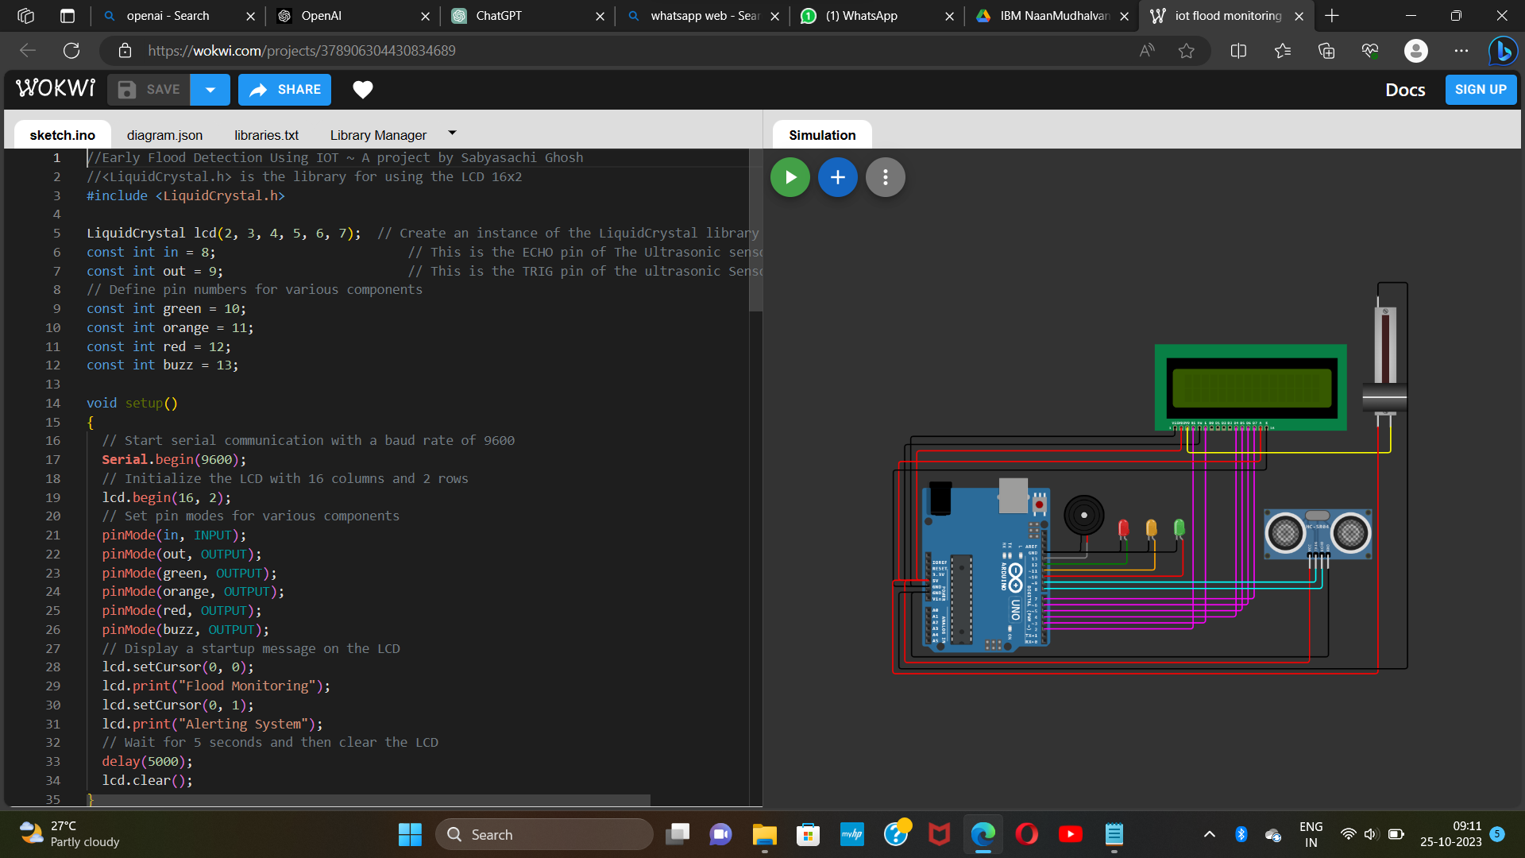

**EXPLANATION:**

IoT is being implemented in the design of this project where it is used as a foundation for data transmissions between the detection devices to the Cloud Ultrasonic sensor and water level sensor used to detect and monitor the level of water from time to time. The system also consists of a flooding avoidance method that uses a solenoid valve to control the excess water flowing out so that the water level can be controlled before flooding occurs. Flood detection and avoidance system not only can create awareness so that citizens can make early preparation after being notified by the mobile phone application, they are also able to monitor water level at any time of the day.

The detection system includes three levels where the water is measured at the safe level, warning level and critical level. Ultrasonic sensors are used to detect the water level and for each level, the depth has been decided where for the condition to be at the safe level, the water must be less than 14cm deep while for warning level, the water has reached a depth between 14cm to 18cm. The critical level is when the water is over 18cm deep. Throughout the three levels, users are able indirectly to monitor the current water level in the drain at a specific location that they desire through an app on their phone. During safe level, a shutter that is used to flow out any excess water will be OFF. This is because there is no triggering danger yet based on the current water level. However, as water continues to rise to the warning level, early warning is given, and the same method applied when the water level reaches the critical level. App users will once again receive a notification alert but this time it will warn users of the critical water level. During both of these situations, the shutter will finally turn ON and therefore will allow excessive floodwater from the drain to flow out to other suitable places.